1. Create two VMs – Name them as Master-node and Worker-node.
2. Take machine type n1-standard 2 CPU
3. Select operating system Ubuntu with size 30GB
4. Run following commands on both VMs

apt-get update

apt-get install docker.io

1. Open the link kubernetes.io on browser and follow the below steps

* Click on documentation (on the top)
* Click on getting started
* Click on production environment
* Installing Kubernetes with deployment tools
* Bootstrapping clusters with kubeadm
* Installing kubeadm

1. Scroll down page and come to below portion

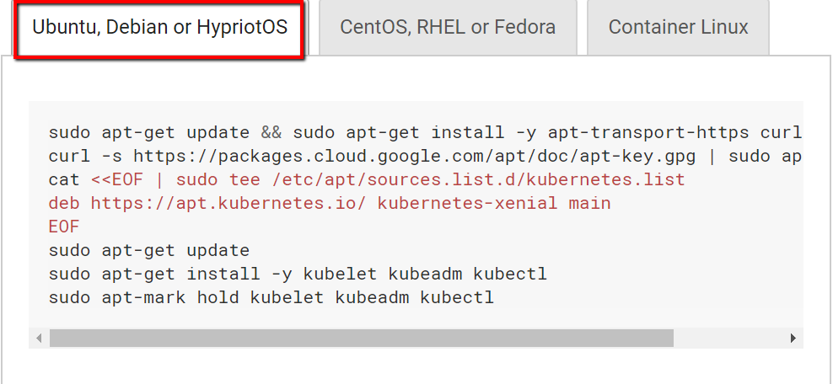

1. Execute mentioned commands on both VMs
2. Now in what’s next section of document – click on Using kubeadm to Create a Cluster
3. **Now run below commands only on Master-Node machine:**

kubeadm init --ignore-preflight-errors=true --config=<configfile.yaml>

After this installation – copy set of instruction to link worker-node. As below:

Your Kubernetes control-plane has initialized successfully! To start using your cluster, you need to run the following as a regular user: mkdir -p $HOME/.kube sudo cp -i /etc/kubernetes/admin.conf $HOME/.kube/config sudo chown $(id -u):$(id -g) $HOME/.kube/configYou should now deploy a pod network to the cluster.Run "kubectl apply -f [podnetwork].yaml" with one of the options listed at: <https://kubernetes.io/docs/concepts/cluster-administration/addons/>Then you can join any number of worker nodes by running the following on each as root:kubeadm join 10.128.0.12:6443 --token fdnyag.pz6c3c1dc78i9mr4 --discovery-token-ca-cert-hash sha256:15a5c2c0b60bfb39fd7fe3cb1fb7252bf0c320bebd2c8df7a27f07a94f72f162

1. Run cluster command on master machine

mkdir -p $HOME/.kube sudo cp -i /etc/kubernetes/admin.conf $HOME/.kube/config sudo chown $(id -u):$(id -g) $HOME/.kube/config

1. Run below join command on worker machine

kubeadm join 10.128.0.12:6443 --token fdnyag.pz6c3c1dc78i9mr4

--discovery-token-ca-cert-hash sha256:15a5c2c0b60bfb39fd7fe3cb1fb7252bf0c320bebd2c8df7a27f07a94f72f162 --ignore-preflight-errors=true

1. Now master node is created but it’s not in ready mode. For this install networking package

Weave net

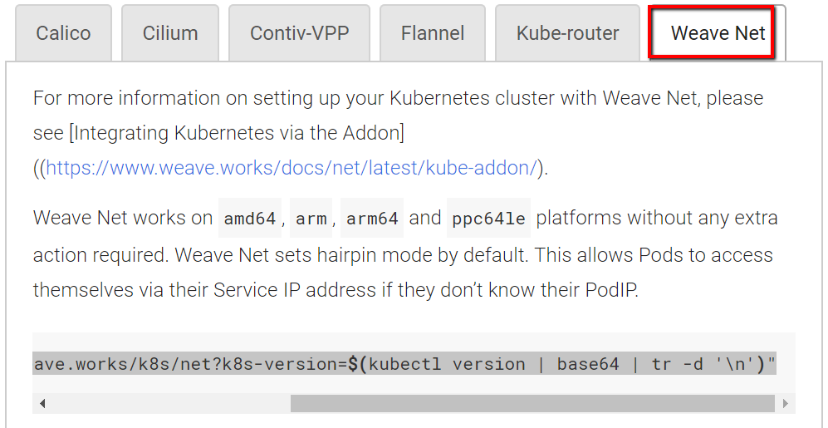

kubectl apply -f "https://cloud.weave.works/k8s/net?k8s-version=**$(**kubectl version | base64 | tr -d '\n'**)**"